Topic: Risk Matrix

Tripti Vishwakarma
Colorado State University Global
Course Code: CSC 501-2
Bingdong Li
Aug 24, 2024

Risk Matrix for Project: Implementing and Design of Software Life Expectancy Model

Probability and Impact Definitions:

- Probability: Low, Medium, High
- Impact: Minor, Moderate, Severe, Catastrophic

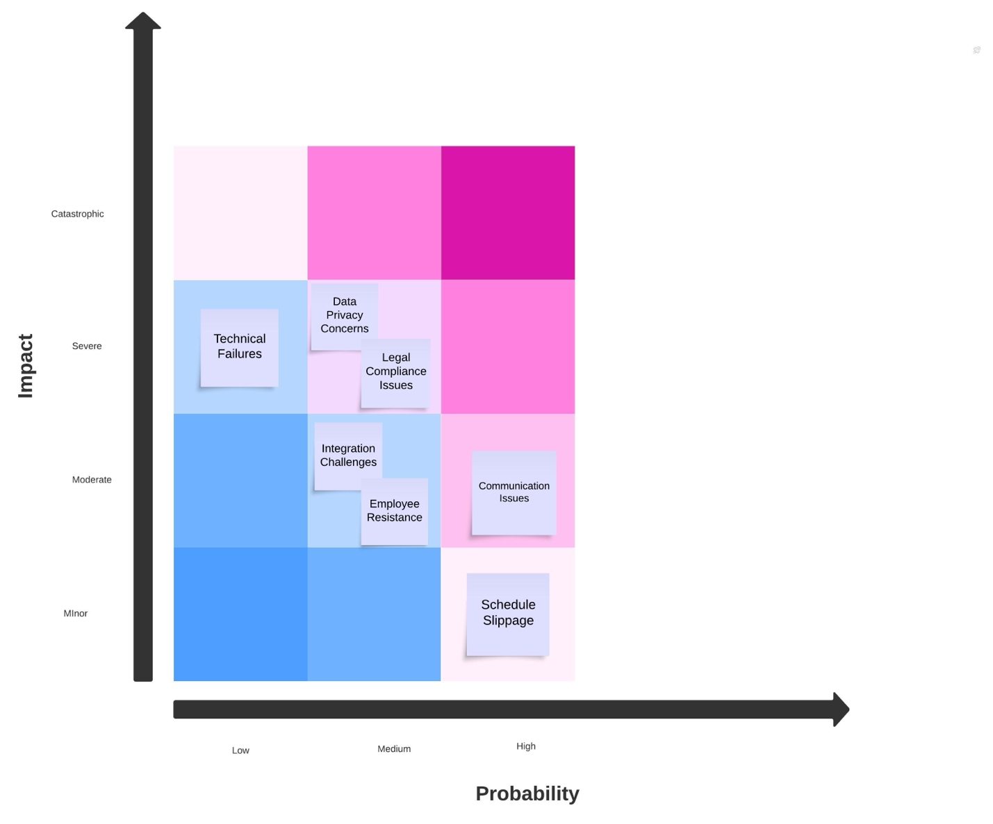

Identified Risks:

- Communication Issues
  - Probability: High
  - Impact : Moderate
  - Risk: High

- Data Privacy Concerns
  - Probability: Medium
  - Impact : Severe
  - Risk: High

- Integration Challenges
  - Probability: Medium
  - Impact : Moderate
  - Risk: Medium

- Technical Failures
  - Probability: Low
  - Impact : Severe
  - Risk: Medium

- Schedule Slippage
  - Probability: High
  - Impact : Minor
  - Risk: Medium

- Legal Compliance Issues
  - Probability: Medium
  - Impact : Severe
  - Risk: High

- Employee Resistance
  - Probability: Medium
  - Impact : Moderate
  - Risk: Medium

Synopsis of Potential Scenarios:

- Communication Issues
  - Potential to Occur: High likelihood due to the large workforce and complexity of the project.
  - Possible Fallout: Misalignment of project goals, delays in deliverables, and reduced project efficiency.

- Data Privacy Concerns
  - Potential to Occur: Medium likelihood due to handling sensitive data.
  - Possible Fallout: Legal repercussions, loss of stakeholder trust, and potential financial penalties.

- Integration Challenges
  - Potential to Occur: Medium likelihood due to the complexity of integrating new models with existing systems.
  - Possible Fallout: Delays in project timeline, increased costs, and potential system downtimes.

- Technical Failures
  - Potential to Occur: Low likelihood with proper testing and validation.
  - Possible Fallout: Severe impact on project deliverables, requiring rework and additional resources.

- Schedule Slippage
  - Potential to Occur: High likelihood due to the project's complexity and potential unforeseen issues.
  - Possible Fallout: Minor impact if managed well but could lead to stakeholder dissatisfaction if not communicated properly.

- Legal Compliance Issues
  - Potential to Occur: Medium likelihood due to the need for compliance with data protection laws.
  - Possible Fallout: Severe legal and financial consequences, project delays, and potential rework.

- Employee Resistance
  - Potential to Occur: Medium likelihood due to changes in processes and systems.
  - Possible Fallout: Decreased productivity, postponements in project phases, and the possible requirement for extra training and change management initiatives.

Risk Mitigation-

- Communication Issues: Given the large workforce, it's essential to establish clear communication channels and protocols. Regular updates and feedback loops can help ensure everyone is on the same page.

- Data Privacy Concerns: Managing sensitive data necessitates rigorous compliance with data protection regulations. Regular training on data privacy for all team members can help mitigate risks.

- Integration Challenges: Integration with existing systems can be complex. Detailed planning and phased integration can help manage this risk.

- Technical Failures: Ensuring robust testing and validation processes can minimize the likelihood of technical failures. Regular maintenance and updates can also help.

- Schedule Slippage: Building in buffer time and regularly reviewing progress can help manage schedule slippage. Clear communication with stakeholders about any delays is crucial.

- Legal Compliance Issues: Regular consultations with legal experts and compliance audits can help ensure adherence to relevant laws and regulations.

- Employee Resistance: Change management strategies, including training and open communication, can help address employee resistance and ensure smooth transitions

By actively recognizing and addressing these risks, the team of this project can better navigate challenges and ensure the project's successful deployment.

References-

  - National Institute of Standards and Technology (NIST). Framework for improving critical infrastructure cybersecurity https://nvlpubs.nist.gov/nistpubs/CSWP/NIST.CSWP.04162018.pdf

  - European Commission (2020), General Data Protection Regulation (GDPR). https://ec.europa.eu/info/law/law-topic/data-protection_en

  - PMBOK® Guide – Seventh Edition https://www.pmi.org/pmbok-guide-standards/foundational/pmbok

  - 24FA-CSC501-2[Based on Project Management Professional (PMP) Based on PMBOK7] https://seu-csuglobal.ucertify.com/app/?func=ebook&chapter_no=14#07ruW

